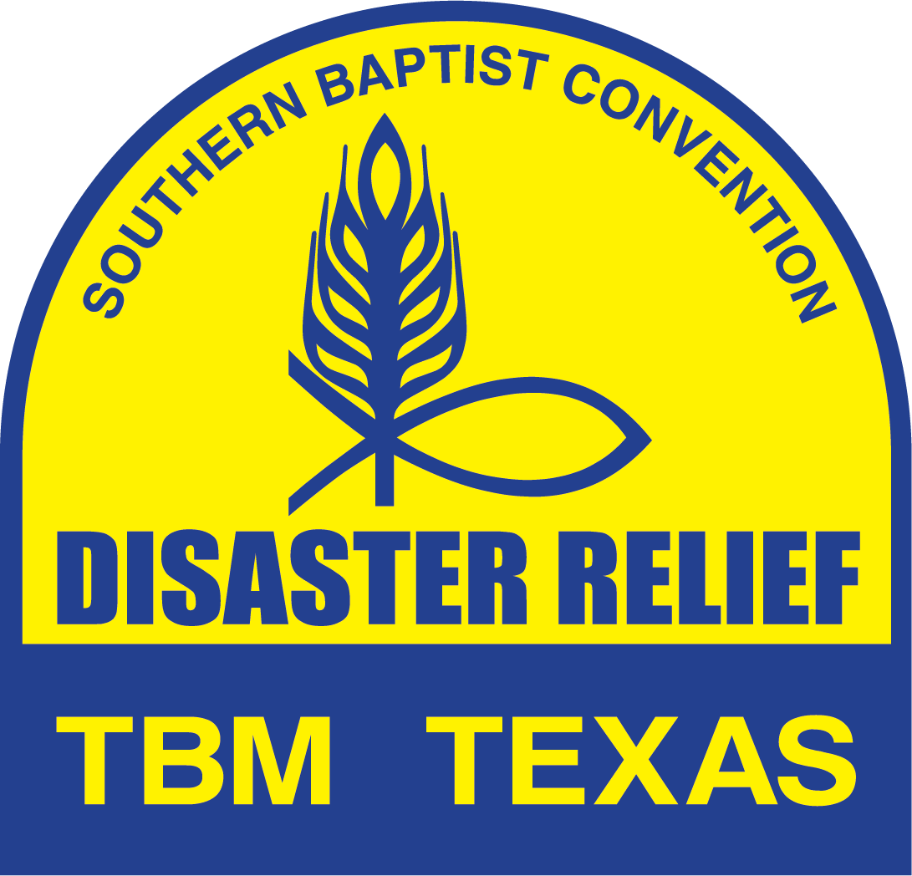

UNIT LEADER
HANDBOOK
Revision: September 4, 2023

TABLE OF CONTENTS Page

SECTION 1 – GENERAL INFORMATION 1
- Definitions 1
- Abbreviations 1
- Unit Names 2
- Unit Numbers 2
- Ministry Definitions 2
- Disaster Relief Key Contacts 2
- TBM Web Site, Numbers and Addresses 3
- IMT Email Addresses 3
- TBM Disaster Numbers 3

SECTION 2 – FORM STACK INSTRUCTIONS 3
- Definitions 3
- General Information 4
- General Instructions 4
- Local Response Instruction 5
- Non-Disaster Reporting Instruction 5
- Rebuild Instructions 6
- Responding Team Roster Submission Form 6
- Responding Team Deployment Notification Report 7
- Reporting Team Arrival Notification Form 7
- Daily Activity Report 7
- Incident Report 9
- Formstack Links and QR Codes 9

SECTION 3 – UNIT LEADER RESPONSIBILITY 11
- Notes 11
- Prior to Departure 11
- Departure (Day 1) 11
- During Travel to Disaster Site 11
- Arrival at Disaster Site 11
- Daily during Call Out 12
- Departure from the Disaster Site 12
- During Travel Home 12
- Conclusion of Call Out 12
- Volunteer Health and Safety 13

SECTION 4 – EXPENSE REIMBURSEMENT 13
- Expense Reimbursement Guidelines 13
- Expense Reimbursement Form 15
- Expense Reimbursement Form Instructions 16

TABLE OF CONTENTS Page

SECTION 5 – VOLUNTEER FORMS 17
- Volunteer Release & Assumption of Risk 17
- Medical Release Form 21
- Disaster Relief Decision Reporting Form 23

SECTION 6 – POLICIES, PROCEDURES AND GUIDELINES 24
- Volunteer Harassment Policy 24
- Dress Code 24
- SUV Philosophy 25
- Social Media Guidelines 27
- Unit Leader Position Description 28
- ICS Introduction 28
- Call Out Procedures 29

SECTION 7 – REFERENCE INFORMATION 31
- Donations 31
- Form Stack Check List 32

SECTION 8 – BIBLE VERSES 33
- Mark 10:43 – 45 33
- Matthew 28:19 33
- Proverbs 27:17 33
- Ephesians 4:26-27 33
- Ephesians 4:29 33

SECTION 9 – TEAM LEADERSHIP SKILLS 33
- Decision Making 33
- Stress Management 33
- Conflict Management 34
- Maintain Balance 34

SECTION 1 - GENERAL INFORMATION
- DEFINITIONS
- “On Site” Location of actual disaster site. Site where team or IMT is
physically located.
- “Off Site” Location of DOC or other command facilities not located at the
actual disaster site.
- Unit Leader Person responsible for team. Unit Leader, Unit Director and
Blue Cap are used interchangeably.
- Administrator Person assisting Unit Leader with administrative activities.
- IMT Incident Management Team
- Command Post TBM Command center for specific deployment. Location of
IMT and check in location for all volunteers.
- R&I-PI Release & Indemnity-Personal Information Form. Current title
for this form is “Volunteer Release and Assumption of Risk Agreement.
- Recovery Definitions
- Work Order Home owner signed document giving team permission to

work on the home owner property.
- Job Subset of a Work Order when more than one function is

required to complete the assignment (chainsaw, Fire Recovery, Flood Recovery, etc.) There may be multiple “Jobs” on one “Work Order”.

- ABBREVIATIONS
- ARC American Red Cross
- BGCT Baptist General Convention of Texas (Texas Baptist
Convention)
- DOC TBM Disaster Operations Center (Dallas)
- DRT Disaster Relief Team
- IC Incident Commander
- ICS Incident Command System
- IMT Incident Management Team
- JAC Joint Assistance Center
- LTR Long Term Recovery
- MARC Multi Agency Resource Center
- NAMB North American Mission Board
- QR Quick Response
- RC Recovery
- SBDR Southern Baptist Disaster Relief
- SBTC Southern Baptist of Texas Convention
- SUV Spontaneous Unsolicited Volunteer
- TBM Texas Baptist Men
- TSA The Salvation Army

- UNIT NAMES
- The Unit Name is selected by the unit to generally describe the unit home location and function.
- The Unit Name is provided to TBM on the Statement of Understanding (Unit Agreement).
- Example: PBCAmarilloCleanout (Paramount Baptist Church, Amarillo, Cleanout Unit)

- UNIT NUMBERS
- The unit ID number is a unique designation for each unit and is generally in a TB x1 x2 x3 x4 x5 format.
- TB Texas Baptist Men
- x1 Unit Type (two letters)
- x2 TBM Area Number (one digit)
- x3 Sequential number assigned by TBM (three digits)
- x4 Unit Designation
- x5 Area Location Description (two digits)
- The unit ID number is assigned by TBM when a unit agreement is executed.

- MINISTRY DEFINITIONS
- Ministry Contact - A Ministry Contact is defined as “prayer with an individual”, “spiritual discussions with an individual”, “encouragement conversation with an individual”, or “providing a spiritual tract for an individual”.
- Gospel Presentation – One on one presentation of the plan of salvation to an individual to the point an individual is presented an opportunity to pray to receive Christ. If the presentation does not reach this point, it should be counted under Ministry Contacts.

- DISASTER RELIEF KEY CONTACTS
- David Wells – TBM Disaster Relief Director
- Cell: 214-668-6977 – Email: David.wells@tbmtx.org
- Rupert Robbins – TBM Assistant DR Director
- Cell: 972-639-7228 – Email: Rupert.robbins@tbmtx.org
- Alicia Enriquez - TBM Disaster Relief Director Administrative Assistant
- Office: 214-275-1177 - Email: Alicia.Enriquez@tbmtx.org
- Robert Howington – Unit Leader Training Coordinator
- Cell: 817-239-5621 - Email: tbmdrchair@tbmtx.org
- John Littrell - TBM Facilities Manager
- Cell: 469-457-2755 Email: john.littrell@tbmtx.org
- Kim Elliott – Disaster Relief Ministry Assistant
- Cell: 214-460-0201 - Email: kim.elliott@tbmtx.org
- Ralph Rogers – DR Reports Coordinator, Operations Data Base Administrator
- Cell: 806-679-4970 - Email: rogers1941@suddenlink.net
- Duane Bechtold – Train the Trainer Coordinator
- Cell: 469-387-9915 – Email: dgbechtold@msn.com
- John Hall – TBM Communications Director
- Cell: 214-908-1391 - Email: John.hall@tbmtx.org
- Sabrina Pinales – Ministry Advancement Coordinator
- Cell: 469-826-4992 – Email: sabrina.pinales@tbmtx.org
- Jim Lawton – IMT Coordinator
- Cell: 469-682-7016 - Email: jimlawton@aol.com
- Ferrell Foster – Associate Director of Communications
- Cell: 214-773-1512 - Email: Ferrell.foster@tbmtx.org
- Sid Riley – Day Volunteers Coordinator
- Cell: 903-810-8600 – Email: redlegfa06@gmail.com

- TBM Web Site, Numbers, and Addresses
- Web Site
- www.tbmtx.org
- TBM FAX NUMBER
- 214-381-7900
- TBM DISASTER RELIEF ADDRESS
- Texas Baptist Men
- 5351 Catron Drive
- Dallas, Texas 75227
- Attn: Disaster Relief

- IMT Email Addresses
- A series of email addresses will be set up for each Command Post activated. (IC, Ops, and Adm). The addresses are designated icx@tbmtx.org for Incident Commander, opsx@tbmtx.org for Operations, and admx@tbmtx.org for Administration. The “x” indicates the designated Command Post and will be 1, 2, or 3.

- TBM Disaster Numbers
- Each disaster where TBM deploys units will be assigned a Disaster Number. The number will be the current year and then 3 digits. The first disaster number will be 2023-001 and then each disaster will be numbers sequentially. The Disaster Number must be shown on the Expense Reimbursement Request Form. The number will be provided on the Formstack briefing sheet.

SECTION 2 – FORM STACK INSTRUCTIONS (09/04/23)
Definitions
- SBDR - Southern Baptist Disaster Relief
- NAMB - North American Mission Board
- IMT - Incident Management Team
- QR - Quick Response
- TBM Declared Disaster – Any disaster response where TBM has assigned a unique Disaster Number. TBM Declared Disasters are determined by the TBM state DR director.

General Information
- The SBDR Reporting System using Form Stack has been developed and implemented by the North American Mission Board. It is the reporting method for all TBM deployments.
- The reporting system can be accessed from any computer, laptop or tablet.
- Each report is linked to all other reports. Once data has been entered in the original report (Roster) it is automatically linked to all other reports.
- All reports are automatically emailed to appropriate personnel. No additional distribution is required by the reporting person.
- The camera on most mobile devices can be used as a QR reader.
- There are multiple reports available. Currently TBM uses five (5) Form Stack reports.
- Responding Team Roster Submission Form
- Submitted as soon as team composition is known
- Submitted any time team composition changes
- Responding Team Deployment Notification Report
- Submitted when the team or unit leaves its home location
- Submitted when the team or unit leaves deployment site for home.
- Reporting Team Arrival Notification at Deployment Location.
- Submitted as soon as possible after arrival at the deployment location.
- Submitted as soon as possible after arrival at home location.
- Daily Report
- Submitted daily including work, travel and rest days
- Incident Report
- Submitted as needed to report injuries or damage to property
- Each report is populated only with the information required for the selections made.

General Instructions
- Select the appropriate link for the desired report or access the QR code.
- Enter data as instructed on the report.
- Insure accurate information. All data entered in the first report is used to populate all other reports. Incorrect information on the first report must be edited on every additional report submitted for the duration of the deployment. Always review entered data before submitting report.
- For all reports “Convention” will always be “Texas – TBM”.
- Unit Number/Team Name – Always use the TBM Unit number of the deploying unit. The unit number is available on the Unit Agreement and is generally also displayed on the unit. Only use a team name if a unit is not being deployed (Security Teams, Feeding Teams, Assessment Teams, IMT, or Chaplain Teams). Replacement teams assigned to a Unit should use the Unit Number of the assigned Unit. Do not use both Unit Number and Team Name. For those units reporting multiple units on the same report such as Chainsaw and Man lift or Chainsaw and skid steer, insert all applicable Unit IDs in the Unit Number/Team Name field. (Example – Chainsaw and skid steer, TBRC727C-7N/TBHE720SS-7N).
- For any special or unique situations, contact the DR Reports Coordinator or DR Information Coordinator for instructions.
- Response and Site information will always be provided by TBM and will be unique for each deployment (Form Stack Briefing Sheet).
- If a report has been submitted with an error, DO NOT resubmit the report unless instructed to do so by the DR Reports Coordinator. The reports can generally be corrected.
- Daily Reports are required each day of deployment including work days, travel to and from the disaster site, and any “rest” days.
- For reporting purposes, all days deployed away from the unit home site including travel and rest days are considered work days. The daily report should include number of volunteers and work hours for each day. For “rest” days an 8-hour day should be used for reporting purposes. All other days will be actual hours worked or hours traveled. The “Work Hours” field is total hours worked by the entire team for the reporting period. Rest days are only reported for those units that are deployed requiring overnight stay. Units commuting each day do not submit a report on days the unit is not working.

Local Units
- Local Response
- Any TBM unit responding to a TBM declared disaster but not requiring support (lodging, feeding, etc.)
- Response: As assigned by TBM and indicated on Briefing Sheet
- Site: 2023 – TBM Local Responses.
- Daily Reports, Rosters, Deployment Report, Arrival Report and Incident Report are required.
- Any TBM unit responding to a Local but non TBM declared disaster (Local disaster) and not requiring support (lodging, feeding, etc.). Response and site will be 2023 – TBM Local Responses.
- Response: 2023 – TBM Local Responses
- Site: 2023 – TBM Local Responses
- Daily Reports and Incident Reports are required. Rosters and other reports are not required.
- Non-Disaster
- Any activity by a TBM unit that is not in response to a local or TBM declared disaster. Examples would be shower unit at a church camp, helping a senior citizen with tree issues, mission projects, etc.
- Response: 2023 – TBM Non-Disaster
- Site: 2023 – TBM Non-Disaster
- Daily Reports and Incident Reports are required. Rosters and other reports are not required.
- Form Stack will always be used to report TBM activity in Local Responses and Non-Disasters.
  - Always select the appropriate box under Activity Reporting which best describes the deployment activity (chainsaw, shower/laundry, feeding, etc.), AND also select the “Not Listed” box which generates an additional drop-down box. Use that box to define the response reason and response location. (Example: Tornado Damage in Denton; High Wind damage in Amarillo, Tornado Damage in LaGrange, etc.)
  - Always complete the various “Jobs Completed” fields as appropriate.

Rebuild Instructions
- Form Stack will always be used to report TBM Rebuild activity.
- Response will always be “2023 – TBM Rebuild” or current year.
- Site (Location) will be unique for each deployment. For example: “2023 – TBM Rebuild – Dallas Area”.
  - The Daily Activity Report and Incident Report (if needed) are the only required reports. Rosters and other Formstack Reports are not required.
  - Always select the “Rebuild” box under Activity Reporting. This provides a field (“Repair/Rebuild Jobs Completed”) to report number of jobs completed.
  - A Rebuild job is considered complete and should only be reported when all planned activity is complete and the homeowner has been presented a Bible.
  - A new TBM Disaster Relief Number will generally not be assigned for Rebuild Deployments. The Rebuild DR number will be the DR number assigned to the original disaster that resulted in the Rebuild activity with an “R” added to indicate Rebuild.

Responding Team Roster Submission Form
- The Team Roster Report should be submitted as soon as team composition has been identified and could be several days prior to departure.
- It is not necessary to submit a new roster when team members depart, only when new team members are added.
- Always select the “substitute Roster” box when submitting a revised roster.
- For Chainsaw, Fire Recovery, Flood Recovery, Repairs, Temporary Roof and Heavy Equipment – Select Recovery, then select the appropriate specialty.
- If Heavy Equipment specialty is selected also select the blank for Heavy Equipment type (Skid steer, Mule, ATV, Tractor, etc.) Note: Man-Lifts are not considered Heavy Equipment.
- For Security Teams and Box Units – Select Other and then complete the blank with the appropriate specialty.
- If the roster is available in a separate MS Excel, MS Word, PDF, JPG or Text file, that document may be up loaded into the Roster form. To upload team roster – Select “Yes” in the appropriate box. The team roster file must be located on the same device from which the report is being generated. Select “Browse” and then select the file on your device containing roster. If the volunteer list changes, update the file, and then resubmit list. This is the preferred method of roster submission.
- After submission of the Team Roster Form the reporting person will receive an email with a copy of the report and a link to the Responding Team Deployment Report. All information entered in the Team Roster Form will automatically populate the Responding Team Deployment Report.

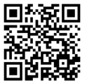
Responding Team Deployment Report
- This report is submitted when the team or unit departs for the deployment location and when the team or unit departs the deployment location for Home.
- After submission of the Responding Team Deployment Report the reporting person will receive an email with a copy of the report and a link to the Responding Team Arrival Report and the Daily Activity Report. All information entered will automatically populate the “next” report.
- If the team anticipated arrival is changed by more than one (1) hour (+ or -) the form should be resubmitted with updated information.
- A DEPLOYMENT REPORT IS REQUIRED FOR TEAMS AND UNITS RETURNING HOME.
- Always check the “returning home” box.
- Note: A Daily Activity Report is required for all deployed days, including travel. For travel days, the selected activity should be “Travel Only”.

Reporting Team Arrival Notification Report
- This report is completed as soon as possible after arrival at the deployment location and as soon as possible after arrival at Home.
- Once the Reporting Team Arrival Notification Report has been submitted a return email will be sent to the reporting person with a link, if needed, to the Daily Activity Report.
- Note: A Daily Activity Report is required for all deployed days, including travel. For travel days, the selected activity should be “Travel Only”.
- AN ARRIVAL NOTIFICATION REPORT IS REQUIRED FOR ALL TEAMS AND UNITS RETURNING HOME.
  - The “Location” will always be “Not Listed” and then fill in the blank with home location.

Daily Activity Report
- This report is completed at the end of each deployed day. Once the Daily Activity Report (first day) has been submitted an email will be sent to the reporting person with a link for the next day report. If a Daily Report is missed, a report may be submitted that covers several days.
- This report is required for all deployed days, including travel. For travel days, the selected activity should be “Travel Only”.
- This report will display information only for the Activities selected.
- “Mudout” – Select “Flood Clean Up”.
- “Boxes” – Select “Mass Distribution”.
- “Asset Protection” – Select “Security”.
- “Ashout” – Select “Fire Clean up”.
- Data fields will only be displayed for those activities selected. More than one activity may be selected if report is being provided for multiple functions. (Such as chainsaw and heavy equipment).
- Chaplaincy should be selected if a trained TBM chaplain has been assigned to your team or IMT or for “stand alone” chaplain teams.
- A “Daily Activity Report” is required for all deployed days including travel and non-work (rest) days. For travel days, the “Activity Reporting” will be “Travel Only” and work hours will be actual hours traveled. For non-work (rest) days the “Activity Reporting” will be “Not Listed”. The activity will then be “rest day” and for reporting purposes, work hours will be 8 hours per day per person. Rest days only apply if the unit is deployed. If a unit is at its home location for a rest day no report is required.
- Ministry contacts by a chaplain assigned to a team should be reported under “Chaplaincy Contacts” while ministry contacts by team members should be reported under “Ministry Contacts”.
- “Work Hours” – Total hours actually worked by all volunteers on the team during the reporting period including SBDR and non SBDR volunteers. For travel days, work hours will be actual hours traveled. For rest days, an 8-hour day should be used. All other days will be actual hours worked.
- “Heavy Equipment Hours” – Total hours Heavy Equipment is in use. Heavy Equipment includes Skid steer, Mule, ATV, Tractor, etc. Note: Man-Lifts are not considered Heavy Equipment.
- Incident Command/Operation/Site Management. When this activity is selected a series of fields under “Cleanup/Recovery Snap Shot” are displayed. Only the appropriate fields that reflect the current deployment should be completed. The requested information should be available from the Work Request Tracking system if the IMT is using that tool.
- Illness, Injury, Property Damage, Other. If one of these events occur, the appropriate box should be checked. When the Daily Report is submitted Form Stack will direct you to the SBDR Incident Report Form. The Incident Report should be completed in as much detail as possible. It is a mandatory report. Form Stack will not process the daily report until the incident report is completed.
- Professions of Faith and Other Decisions should be recorded in the appropriate fields. If decisions are reported the “Yes” box under “Needs Follow-up” should also be checked. This provides a drop-down text box, “People to Follow Up”, to enter name (first and last), address (City, State, Zip), contact information (Telephone Number), Approximate age, and description of decision. The Disaster Relief Decision Card should also be completed and returned to the IMT Chaplain or local church if IMT not on site.
- If any of the decision fields are completed, Form Stack will direct you to an Evangelistic Response Form. TBM is not using this form – Do not complete. Simply delete the form and the Daily Report will be automatically submitted.
- For those units reporting multiple units on the same report such as Chainsaw and Man lift or Chainsaw and skid steer, insert all applicable Fleet IDs in the Unit Number/Team Name field. (Example – Chainsaw and skid steer, TB RC 727C/TB HE720 SS).

Incident Report
- This report is completed anytime any box under “Items to Report” on the Daily Report is selected including Injury/Illness, Property Damage, and Other.
- It is a mandatory report and form stack will not submit the associated daily report until the Incident report has been completed.
- If submitted from the Daily Report the contact fields are populated from the Daily Report information.
- The Incident Report can also be used as needed as a “stand alone” report.
- If the Incident Report is submitted as a “stand alone” report all field must be completed at time of submission.
- The report should be completed with as much detail as possible.
- Convention DR Director is the TBM State Director.
- Use the “Injuries” field, “Damage Description field”, or “What happened field” to include information such as: treated on site, took to hospital, called police, took day off, vehicle undrivable, etc.

Formstack Links and QR Codes

Responding Team ROSTER
- https://SBDR.formstack.com/forms/team_roster_form
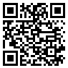

Reporting Team DEPLOYMENT
- https://SBDR.formstack.com/forms/deployment_notification
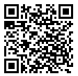

Reporting Team ARRIVAL at Deployment Location
- https://SBDR.formstack.com/forms/arrival_notification
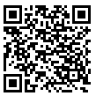

DAILY Activity Report Form
- https://SBDR.formstack.com/forms/daily_report
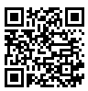

INCIDENT REPORT
- https://SBDR.formstack.com/forms/Incident_report
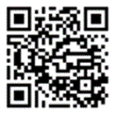

SECTION 3 - UNIT LEADER RESPONSIBILITY
- Notes
- It is the Unit Leader’s responsibility to ensure that all volunteers deploying with their unit or team have current credentials. Non-yellow cap trained volunteers or volunteers whose badge has expired are considered SUV’s. In some instances, SUV’s may deploy with a TBM Disaster Relief Unit. Refer to the current TBM SUV philosophy for guidelines. TBM will generally not reimburse expenses for SUV’s.
- During deployment Unit Leader’s should maintain location information about each volunteer assigned to their team including:
- Lodging Information (location and room)
- Location if away from disaster site
- During deployment Unit Leader’s should keep cell phones on and available at all times (24/7). The Unit Leader is the emergency contact for volunteers assigned to their team.
- All deployed units are required to submit all necessary reports during deployment and at the conclusion of the deployment.
- It is the Unit Leader’s responsibility to ensure all reports are completed in a timely manner. The Unit Leader may use an Administrative Assistant as needed.
- The Unit Leader should obtain copies of the Disaster Relief Decision Reporting Card as needed.

- Prior To Departure
- Ensure all deploying volunteers have a current TBM Disaster Relief badge. Exceptions must be approved by the state DR Director.
- Submit Responding Team Roster Submission Form. THE ROSTER SHOULD BE SUBMITTED AS SOON AS TEAM COMPOSITION IS KNOWN AND MUST BE SUBMITTED PRIOR TO DEPARTURE. IT SHOULD BE UPDATED IF THE TEAM COMPOSITION CHANGES.

- Departure (Day 1)
- Ensure each volunteer has completed the Medical Release Form and the Release & Indemnity – Personal Information form prior to departure. All forms must be the current revision as found on the TBM website and must be signed originals.
- Release and Indemnity Agreement-PI - See Volunteer Forms.
- Medical Release Form – See Volunteer Forms.
- Submit Responding Team Deployment Report

- During Travel to Disaster Site
- It is recommended that travel be planned such that arrival at the disaster site will be before 8:00 PM. Anticipated late arrival should be approved in advance by the Incident Commander.
- A Daily Report is required for each day of travel. Travel hours are considered work hours.

- Arrival at Disaster Site
- Check in at Command Post
- Texas Sites (TBM Command Post): The Unit Leader will check in his team at the Command Post and provide the TBM Release and Indemnity-PI forms for all team members. The Command Post is responsible for providing the forms to TBM at the conclusion of the deployment. The Unit Leader maintains the Medical Release Form.
- Texas Sites (Non TBM Command Post) and Out of State Sites: The Unit Leader will check in his team at the Command Post or as otherwise directed. The Unit Leader will maintain the Release & Indemnity – Personal Information form and provide those to TBM at the conclusion of the deployment. The Unit Leader maintains the Medical Release Form. Additional form may be required for out of state deployments.
- Housing, meals, schedules, and other information will be provided at check in.
- Submit the Reporting Team Arrival Notification Report
- Submit Daily Activity Report

- Daily During Call Out
- Acquire new Medical Release (Release and Indemnity-PI forms should be completed on-line) for all new volunteers joining the team. This includes all volunteers except home owner and home owner’s family.
- Report names of volunteers who have departed each day to the IMT.
- Complete Daily Activity Report (including travel and rest days). Reports should be submitted no later than 8:30 PM.
- Update Responding Team Roster Submission Form as needed with new arrivals.
- Complete Incident Reports (on line form) as needed.
- Complete work requests (Recovery Units). All completed work requests should be turned in to the IMT. For out of state deployments the Unit Leader should maintain a list of all completed work requests.
- Responsible for team and work assignments.
- Complete Disaster Relief Decision Reporting Card as needed to report spiritual decisions.
- Depending on the number of units deployed and the direction of the onsite Incident Commander, the Unit Leader may also be responsible for the following:
- Daily Devotional, Daily Debrief or Orientation.

- Departure from Disaster Site
- Advise IMT of team/unit departure plans with list of volunteers departing.
- Complete Responding Team Deployment Report. Always check the “returning home” box.

- During Travel Home
- A Daily Report is required for each day of travel. Travel hours are considered work hours.

- Conclusion of Callout (Arrival at Home)
- Complete final Daily Activity Report
- All Medical forms should be returned to individual volunteers or shredded.
- For “Out of State” deployments, the Unit Leader is responsible for providing TBM with the TBM Release and Indemnity-PI form for each volunteer deployed with the unit or team.
- Submit Volunteer Expense Reimbursement Form
- Submit Reporting Team Arrival Notification Report.
- The “location” will always be “Not Listed” and then fill in the blank with home location.

- Volunteer Health and Safety
- Unit Leaders should regularly conduct “tailgate” safety meetings emphasizing work place safety and advising volunteers of unusual hazards or other safety issues. A Safety Briefing form is available from the IMT to document safety meetings, if needed.
- A Health and Safety Office should be appointed to monitor volunteer safety and health if unusual conditions exist.

SECTION 4 – EXPENSE REIMBURSEMENT (9/20/22)
Expense Reimbursement Guidelines
General Information
- It is the mission of Texas Baptist Men (TBM) to engage men and their families in missions. It is in this spirit that TBM has provided these guidelines to facilitate its members in responding to God's call to ministry.
- If a situation exists that is not covered by these guidelines, please contact the State Disaster Relief Director or his designated representative for consideration.
- All requests for reimbursement must be submitted on the currently approved Expense Reimbursement Form available from the TBM disaster relief web site within 30 days of the occurrence of the expense. Expense reimbursements may require 2 -3 weeks for processing.
- All reimbursement requests must be submitted to:
Texas Baptist Men
Attn: Disaster Relief
5351 Catron
Dallas, Texas 75227
- TBM will not reimburse expenses for volunteers that do not have current credentials.

Unit Travel Expenses
- To qualify for mileage reimbursement for a Unit Towing Vehicle.
- A minimum five (5) day deployment is required. Reimbursement of expenses for units deployed for less than the requested time MUST be pre-approved by the State Disaster Relief Director or his designated representative prior to deployment.
- A unit must have a current Unit Agreement.
- A unit must be activated by TBM. Any unit self-deployed or associated unit deployed without approval of TBM WILL NOT be reimbursed.
- Unit Towing Vehicle mileage expenses will be reimbursed at $1.00/mile.
- When the unit is actually being towed
- If the unit towing vehicle is used for other functions, reimbursement for that vehicle for those functions will be at $0.27 per mile with a minimum of two (2) occupants for those miles not towing the unit.
- Feeding Units are reimbursed for the primary unit towing vehicle and one (1) support vehicle.
- Mileage reimbursement expenses will only be paid to the association or church indicated on the Unit Agreement as “Owner” of the unit. Mileage reimbursement expenses CANNOT be paid to an individual. If the “Owner” of a unit is not an association or church the “Owner” must be registered as a 501 C3 organization.
- Starting and ending odometer readings are required to document actual mileage.
- Any exceptions must be approved prior to departure by the State Disaster Relief Director or his designated representative.
Individual Travel Expense
- To qualify for mileage reimbursement a minimum five (5) day deployment is required. Reimbursement of expenses for volunteers deployed for less than the requested time MUST be pre-approved by the State Disaster Relief Director or his designated representative prior to deployment.
- To qualify for mileage reimbursement each vehicle used to deploy volunteers must have a minimum of two (2) occupants. Vehicles with less than two (2) occupants will not be reimbursed. Vehicles with two (2) or more occupants will be reimbursed at the rate of $0.27/mile.
- Volunteers on specific assignments requiring travel with less than two occupants or less than five (5) day deployment may be reimbursed at the rate of $0.27/mile. The assignment must be specific and approved by the State Disaster Relief Director or his designated representative.
- Any exceptions must be approved prior to departure by the State Disaster Relief Director or his designated representative.

Air Travel
- Air Travel will be authorized on a case-by-case basis and must be pre-approved by the State Disaster Relief Director or his designated representative. Reimbursement will not be provided if travel has not been pre-approved by the State Disaster Relief Director or his designated representative.

Lodging
- Double occupancy rooms are required for lodging.
- Reservations should be made by TBM when possible.
- All lodging must be pre-approved by the State Disaster Relief Director or his designated representative. Lodging expense not pre-approved by the State Disaster Relief Director or his designated representative will not be reimbursed.

Meals
- When traveling to or returning home from a disaster site in excess of 100 miles, TBM will reimburse for one (1) meal a day per person not to exceed $18.00 per day per person.
- All reimbursement requests must be supported by original itemized receipts with the names (Signature preferred) of each person included in the cost of the meal on the back of the receipt.
- During deployment, meals will generally be provided by a deployed Feeding Unit, local church or by other arrangements. Any deviations that require meals to be purchased must be pre-approved by the State Disaster Relief Director or his designated representative.

Other
- Actual fuel cost will be reimbursed for generators, chainsaws, pressure washers, and heavy equipment.
- Actual cost will be reimbursed for Shower/Laundry Unit supplies (soap, etc.).
- All requests must be supported by original itemized receipts.
- Other Unit expenses will be considered for reimbursement on a case-by-case basis and must be approved by the State Disaster Relief Director or his designated representative.

EXPENSE REIMBURSEMENT FORM (9/20/22)

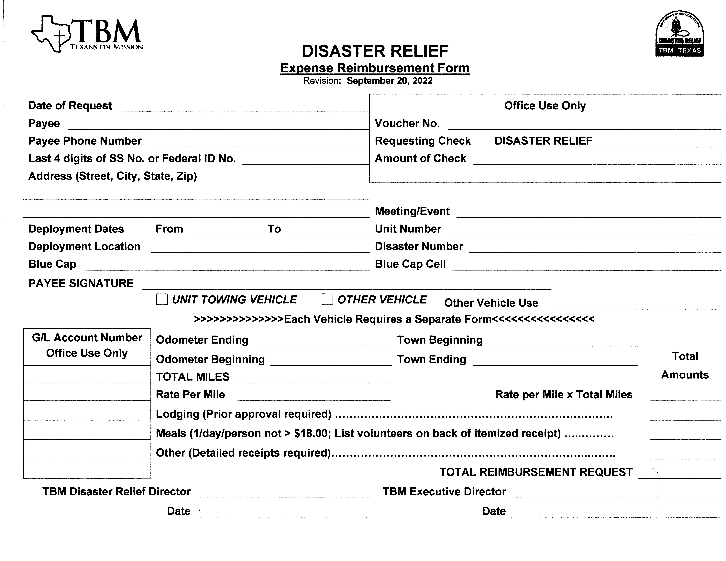
EXPENSE REIMBURSEMENT FORM INSTRUCTIONS (9/20/22)
Notes
- All reimbursement request forms must be submitted to the TBM DR Administrative Assistant. The latest form should be downloaded from the TBM website. (www.tbmtx.org and go to Disaster Relief. Select Volunteer Portal, Forms and Polices and then select the desired form) and may be printed on plain white paper. Reimbursement request on “out of date” forms cannot be processed.
- All receipts must be the original and should be taped to an 8”x10” blank white sheet (more than one receipt may be taped to a page). The receipts should be separated by categories noting the total on the page (i.e., meals, fuel, lodging, etc.).
- A receipt is required for all meals. The tip may be included if it is shown on the receipt. All individuals included in the meal should sign the back of the original receipt. For large groups, a separate list may be provided.
- A receipt is required for all lodging. Prior TBM approval is required.
- Reimbursement rates vary for vehicles depending on activity and circumstances. Refer to Expense Reimbursement Guidelines for approved rates.
- Each person or organization receiving reimbursement must have a W9 or Federal Tax ID on file with TBM. For vehicles transporting volunteers, include list of names riding in vehicle on back of Expense Reimbursement form.
- Unless previously approved by the State Director, all vehicles must have a minimum of two (2) people, Driver plus one (1) passenger, to qualify for reimbursement.
- A separate form is required for each vehicle.
- A separate form is also required for different uses of the same vehicle resulting in a different reimbursement rate per mile. (Example: Towing vehicle used to transport volunteers or supplies while not connected to the unit)

Reimbursement Form Instructions
- Date of Request: Date form completed.
- Payee: Name of person if individual. Name of 501 C3 organization if not individual.
- Payee Phone Number: Phone number of person or organization listed as Payee.
- Last 4 Digits of SS Number or Federal ID No.: Last four (4) digits of Social Security number of Payee if individual or Federal ID number if organization.
- Address (Street, City, State, Zip): Street, City, State, and Zip where reimbursement is to be mailed.
- Deployment Dates: From: First date of deployment. To: Last date of deployment.
- Deployment Location: Location of deployment. Generally, will be location where lodging is provided.
- Blue Cap: Unit Leader (Blue cap) responsible for the deployed unit or team.
- Payee Signature: Signature of individual Payee or responsible person if organization.
- Voucher No.: Leave blank – office use only.
- Requesting Check: Disaster Relief (Do not change – office use only)
- Amount of Check: Leave blank – office use only.
- Meeting/Event: Name of meeting or event associated with the reimbursement request. For disaster response, this will generally be the Form Stack Response name.
- Unit Number: TBM Unit Number. Leave blank if a unit was not deployed.
- Disaster Number: Disaster number supplied by TBM.
- Blue Cap Cell: Cell number of Unit Leader (Blue Cap)
- G/L Account Number: Leave blank – office use only.
- UNIT TOWING VEHICLE: Check this box if reimbursement request is for a vehicle towing a unit.
- OTHER VEHICLE: Check this box if reimbursement request is for any vehicle except a unit towing vehicle.
- Other Vehicle Use: This field must be completed if “Other Vehicle” box is checked. Short description of vehicle use – Volunteer transportation, Feeding support, etc.
- Odometer Ending: Odometer reading at end of deployment
- Odometer Beginning: Odometer reading at beginning of deployment
- Total Miles: Difference between beginning and ending odometer readings.
- Town Beginning: Location at start of deployment (usually home location)
- Town Ending: Location at end of deployment (usually home location)
- Rate Per Mile: Rate is dependent on circumstances. Refer to Expense Reimbursement Guidelines for rate.
- Total Amount: Total reimbursement request for each section – Miles, Lodging, Meals and other.
- Lodging (Prior Approval Required): Total cost of lodging. Receipts required.
- Meals (1/day/person not > $18.00: Total cost of meals. Receipts required.
- Other: Any other reimbursable expense. Each expense requires a receipt.
- Total Reimbursement Request: Sum of items from “Total Amount” column.
- TBM Disaster Relief Director: Signature of TBM DR State Director
- Date: Date signed by TBM DR State Director
- TBM Executive Director: Signature of TBM Executive Director
- Date: Date signed by TBM Executive Director.
Please send completed forms and receipts to:
Texas Baptist Men
Attn: Disaster Relief
5351 Catron
Dallas, Texas 75227

SECTION 5 – VOLUNTEER FORMS

These forms are available from the TBM web site or from the On Site IMT. The latest forms must be used. Out of date forms are not acceptable.

Volunteer Release and Assumption of Risk Form (4/23/20)
- All volunteers must complete the Volunteer Release and Assumption of Risk Form (R&I – PI Form). Volunteers are required to complete the form on-line which can be found on the TBM website. (www.tbmtx.org and go to Disaster Relief. Select the Volunteer Portal, Forms and Polices and then select the desired Form.) The Unit Leader should ensure this step is complete prior to departure for deployment.

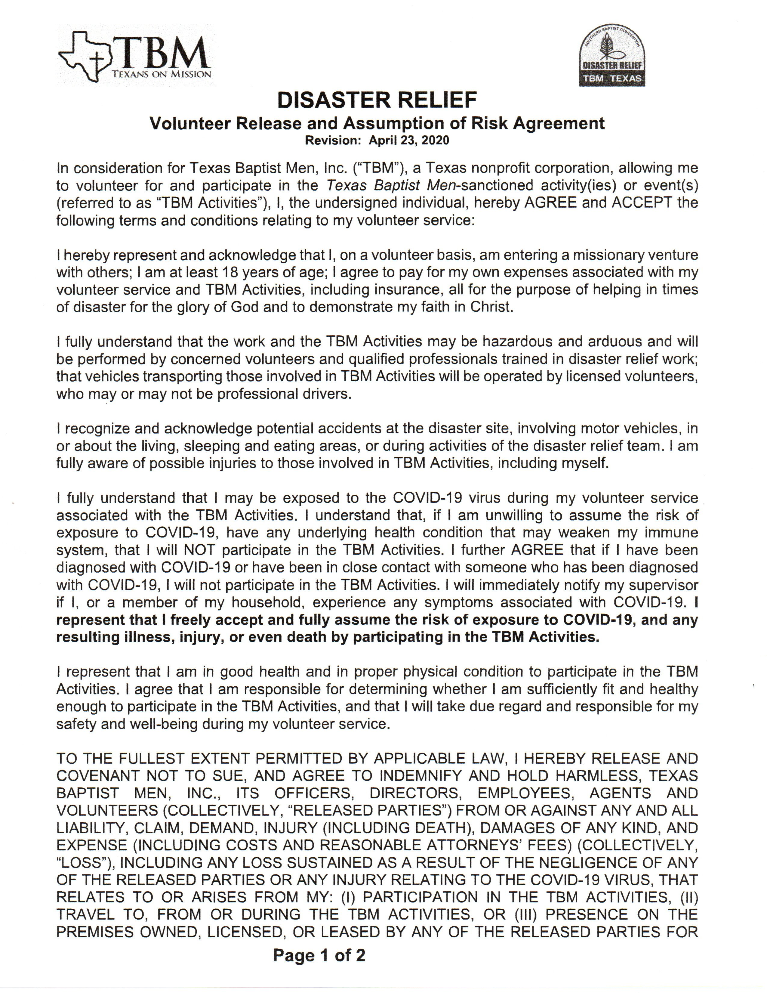

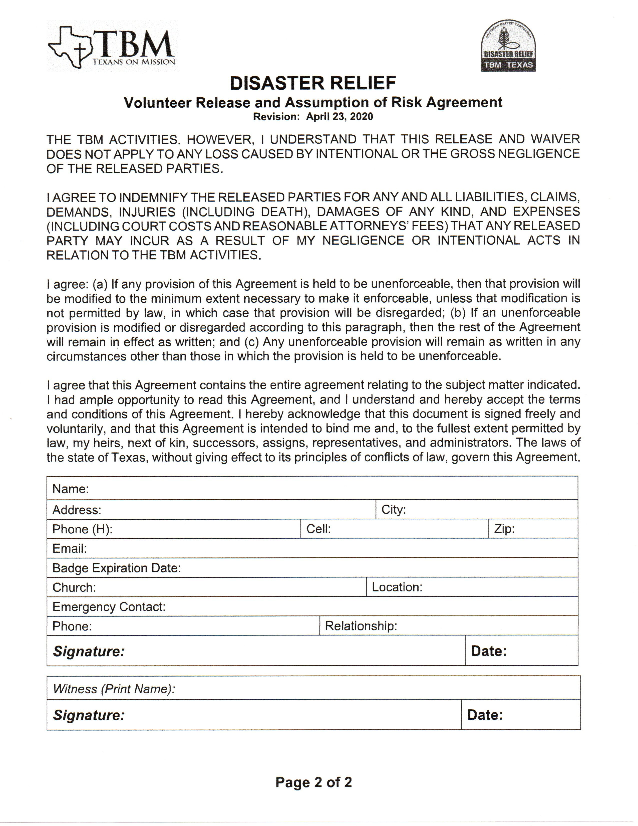

VOLUNTEER RELEASE AND ASSUMPTION OF RISK FORM INSTRUCTIONS
Based on Online Form Dated 4/23/20
- Name: Printed name of volunteer.
- Address: Primary address of volunteer.
- City: City of volunteer
- Phone (H): Home telephone number of volunteer
- Cell: Cell number of volunteer
- Zip: Zip code for address of volunteer.
- Email: Email address of volunteer.
- Badge Expiration Date: Expiration date of disaster relief badge.
- Church: Name of church where volunteer is a member.
- Emergency Contact: Emergency contact for volunteer.
- Phone: Primary telephone number of emergency contact.
- Relationship: Relationship of emergency contact and volunteer.
- Signature: Online Signature of Volunteer.
- Date Signed: Date Volunteer signed document.

- Medical Release Form (1/1/20)
- All volunteers must complete the Medical Release Form.
- The Unit Leader should collect all forms from volunteers and insure completeness prior to departure for deployment.
- The Medical Release Form should be as complete as possible including medication and is signed and dated by the volunteer. The Medical Release Form will generally be maintained by the Unit Leader. It is the Unit leader’s responsibility to ensure that all volunteers have provided the Medical Release Form prior to departure for disaster site.
- When a volunteer moves to a new team, the current Unit Leader is responsible for transferring the Medical Release Form to the new Unit Leader.
- All Medical Release Forms should be returned to the volunteer upon completion of the deployment or disposed of in a secure manner.

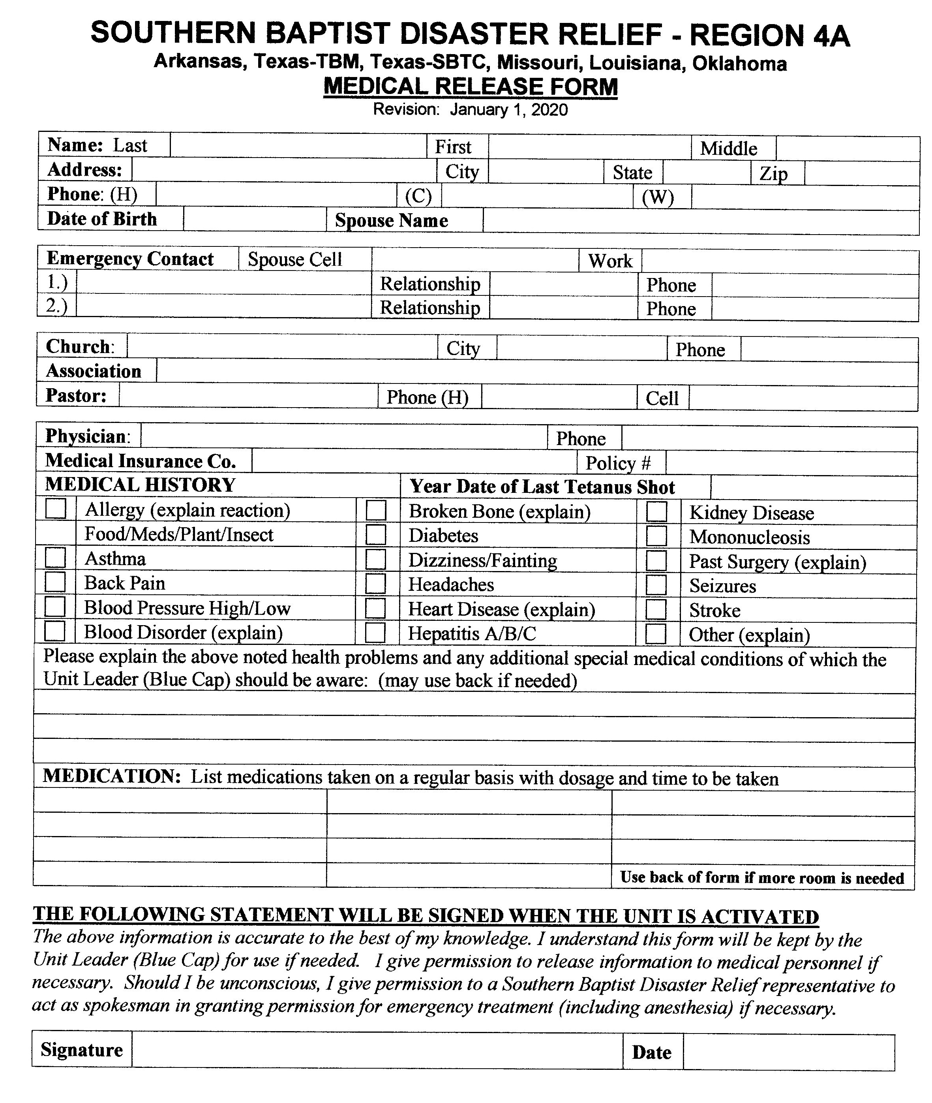

MEDICAL RELEASE FORM INSTRUCTIONS
Based on Form Dated 1/1/20

- Name, Last: Last name of Volunteer.
- First: First name of Volunteer.
- Middle: Middle name of Volunteer
- Address: Street name and number for Volunteer.
- City: City associated with address from item 4.
- State: State associated with City from item 5.
- Zip: Zip Code associated with City from item 5.
- Phone (H): Home telephone number of Volunteer.
- Phone (C): Cell telephone number of Volunteer. Leave blank if not applicable.
- Phone (W): Work telephone number of Volunteer. Leave blank if not applicable.
- Date of Birth: Date of Birth of Volunteer.
- Spouse Name: First and last name of Volunteer’s Spouse. Leave blank if not applicable.
- Spouse Cell: Cell number for Volunteer’s Spouse. Leave blank if not applicable.
- Spouse Work: Work number for Volunteer’s Spouse. Leave blank if not applicable.
- Emergency Contact 1: First emergency contact, first and last name. Cannot be Spouse.
- Emergency Contact 1 Relationship: Relationship of Volunteer to first emergency contact.
- Emergency Contact 1 Phone: Contact number for first emergency contact.
- Emergency Contact 2: Second emergency contact, first and last name.
- Emergency Contact 2 Relationship: Relationship of Volunteer to second emergency contact.
- Emergency Contact 2 Phone: Contact number for second emergency contact.
- Church: Church name where Volunteer is a member or generally attends.
- City: City where church identified in item 21 is located.
- Phone: Telephone number of church identified in item 21.
- Association: Association name which includes church identified in item 21.
- Pastor: Pastor of church identified in item 21.
- Phone (H): Home telephone number of Pastor identified in item 25.
- Cell: Cell telephone number of Pastor identified in item 25.
- Physician: First and last name of primary care Physician for Volunteer.
- Phone: Telephone number for Physician identified it item 28.
- Medical Insurance Co.: Name of Medical Insurance Company for Volunteer.
- Policy No.: Policy number for insurance identified in item 30.
- Medical History: Select all boxes that apply to Volunteer.
- Tetanus Shot: Date of last Tetanus Shot.
- Health Details: Explain in detail any health issues not covered in item 32 or which need special attention.
- Medications: List all medications taken on a regular basis, including name, dosage, and interval medication is taken.
- Signature: Signature of Volunteer.

Decision Reporting Form (1/1/20)

This form is used to document all spiritual decisions reported by the team.

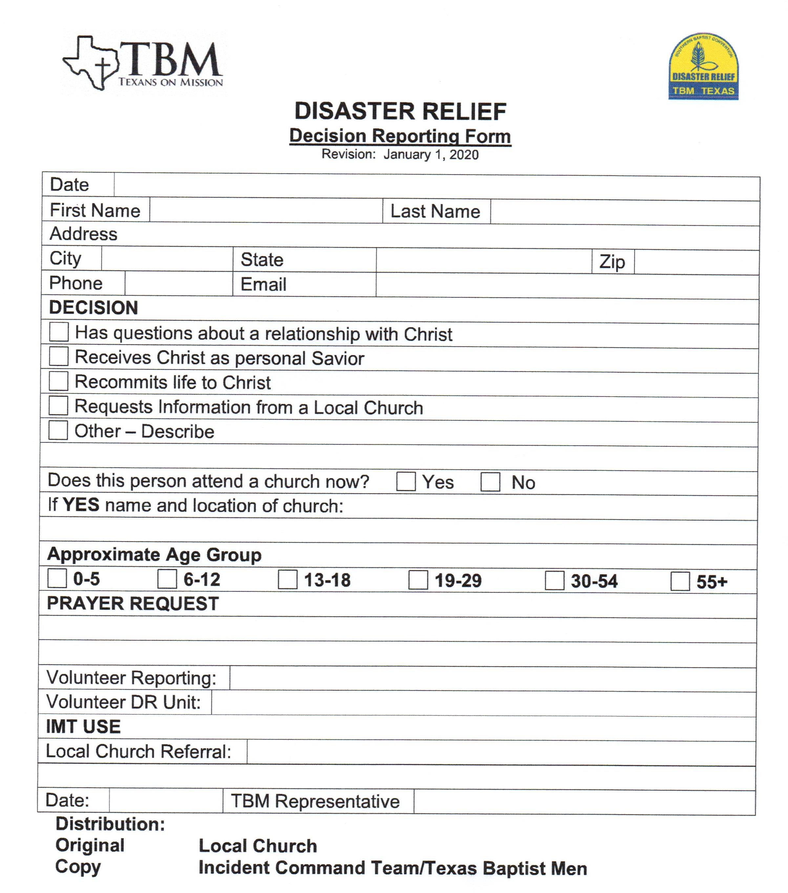

- Complete all fields and check boxes on the Form. Return the completed form to the IMT Incident Commander.

SECTION 6 – POLICIES, PROCEDUES & GUIDELINES
1. Volunteer Harassment Policy (1/1/20)
Texas Baptist Men is committed to ensure a work environment for all volunteers which is fair, humane, and respectful, and an environment which upholds Christian morals and ethics described and mandated by Jesus Christ.
Verbal or physical conduct that shows hostility toward an individual or group and includes derogatory comments, slurs, jokes, innuendos, cartoons, pranks, or physical harassment is prohibited.
Unwelcome sexual advances, requests for sexual favors, and other verbal and physical conduct of a sexual nature constitute sexual harassment when such conduct has the purpose or effect of unreasonably interfering with an individual’s work or performance or creating an intimidating, hostile, or offensive work environment.
Every volunteer is responsible to ensure that the spirit and intent of TBM goals and harassment policies are achieved. Volunteers have the right to be free from harassment.
If a volunteer believes he or she is being harassed, the volunteer is requested and encouraged to make a complaint to TBM. Volunteers are not required to first complain to the person harassing them. The volunteer may complain directly to their immediate Supervisor, Unit Leader, Incident Commander or directly to the TBM State Disaster Relief Director. Any of the individuals above will take the appropriate steps to ensure that prompt and effective remedial action is taken as necessary. All information will be handled in as confidential manner as is possible. Volunteers will not be retaliated against in any way for making a good faith complaint or report of harassment or for assisting in good faith in the investigation of any such complaint or report. Any suspected retaliation or intimidation should be reported immediately to one of the persons described above. Harassment is a violation of federal and state law as well as TBM policies. Confirmed harassment will result in prevention of the individual from future participation in TBM Disaster Relief activities.
TBM will promptly and thoroughly investigate any complaint or report of harassment or
violation of this policy. The State Disaster Relief Director is responsible for investigation of all complaints. A thorough investigation can take several days to several weeks depending upon circumstances and the report. Volunteers may ask the person to whom they reported the harassment or the State Disaster Relief Director’s office for the status of the investigation.
TBM will take prompt remedial action if its investigation shows a violation of this policy.
Depending on the circumstances, the action may range from a warning to termination of all opportunities to volunteer with TBM.
A complaint or report that this policy has been violated is a serious matter. Complaints or reports that are unfounded are also against our policy, and TBM will take appropriate

action if its investigation shows that deliberately dishonest or bad faith accusations have been made.

- DISASTER RELIEF DRESS CODE (1/18/21)
All volunteers must dress in a manner that is conservative, modest, and honoring to our Lord.
WORK HOURS
- Long pants: no spandex, spanks, or shorts. Any exceptions must be approved by the onsite Unit Leader or Incident Commander.
- TBM shirts: yellow or blue t-shirts, denim, postal blue, yellow, or other shirts (short or long sleeves) purchased from TBM are preferred. However, any shirt may be worn with the exception of tank tops, sleeveless shirts, or any shirt with wording or logos that are not conservative, modest, and honoring to our Lord.
- TBM Cap, hat or visor are preferred. However, any cap may be worn except those with wording or logos that are not conservative, modest, and honoring to our Lord.
- TBM DR badge.
- Safety and personal gear as required/approved by Unit Leader.
- All footwear must meet the approval of the Unit Leader.

AFTER HOURS
Whether volunteers are staying in a church or other facility they must at all times maintain the decorum of glorifying our Savior. Particularly in a church, volunteers must be respectful of the church’s worship schedules and activities. Volunteers must dress modestly at all times, being particularly cautious going to and from the shower and restroom facilities. Do NOT walk-through church services or meetings or come to meals in clothing not approved by the dress code as follows:
- Shirts must be worn at all times.
- Do not wear see-through or revealing clothing.
- During sleeping hours when moving about, wear robes, housecoats, or t-shirts and shorts meeting the “finger-tip” rule for shorts. (The fingertip rule …. this means shorts must fall below the fingertips of the wearer when the arms are at their side)
- Casual footwear including sandals/flip flops are acceptable in the facilities unless otherwise indicated by TBM.
Failure to comply with wearing appropriate attire as outlined above is grounds for sending a volunteer home.

- SUV PHILOSOPHY (1/18/21)
Definitions:
SUV Spontaneous Unsolicited Volunteer
VRC Volunteer Reception Center
IMT Incident Management Team

Notes:
- Spontaneous Unsolicited Volunteer, Spontaneous Unaffiliated Volunteer, and Walk on Volunteer are used interchangeably.
- Non-trained volunteers from a Unit’s local area travelling with a local unit are not considered to be SUV’s.
- An SUV is defined as an untrained volunteer and generally:
- Are not part of a recognized voluntary agency
- Have no formal training
- Have not been officially invited
- Generally motivated by a desire to help
- May come from disaster area or outside of the area
- May come one at a time or in small or large groups.
- Could be previous Yellow Cap Volunteers whose credentials have expired.
General Guidelines
- All SUV’s must complete a TBM Volunteer Release and Assumption of Risk Agreement and Medical Release Form prior to working with a TBM team.
- If SUV will not complete the required forms, they will not be permitted to work with a TBM team.
- SUV’s may be rejected due to inappropriate dress, inappropriate behavior, and other factors deemed inappropriate by TBM Leadership. Volunteers rejected should be referred to the VRC or other groups organizing volunteers.
- The decision to allow individual SUVs to work with a TBM team will be made at the lowest level possible, generally by the Blue Cap responsible for the team.
- TBM Leadership (Blue Cap, White Cap) have the authority and responsibility to accept or reject any SUV.
- SUV’s may be required to attend an orientation meeting prior to working with a TBM team.
- SUV’s will generally not be allowed to operate chain saws, other power equipment, or heavy equipment.
- SUV groups may be assigned unique work orders or broken up and assigned to existing TBM teams.
- Individuals that do not represent a “like” belief in Jesus Christ, may, at the discretion of TBM leadership, be assigned to work with a TBM team. (This could give the TBM team an opportunity to witness to a non-believer). Individuals not allowed to work with a TBM team should be referred to the VRC.
- Non-Church Groups that do not represent a “like” belief in Jesus Christ will not be allowed to volunteer with a TBM team or work under TBM direction and should be referred to the VRC. TBM may, however when requested, provide coordination of those groups.
- Church Groups that do represent a “like” belief will be allowed to work with TBM teams and/or under TBM direction based on available work and need.

Process/Procedure
- Individual – TBM Leadership (generally the Blue Cap) will interview SUV and determine if SUV may work with TBM team.
- Groups – At TBM Leadership discretion, Leadership will interview the group leader or all of the SUV’s and determine if SUV group may work with TBM team.
- The decision to allow a particular SUV or group to work with a TBM team is guided by the following.
- TBM’s primary purpose is to minister to survivors and share the love of Jesus. Any volunteer that would act contrary to that purpose should not be allowed to work with a TBM team.
- TBM Leadership makes determination that there is sufficient and appropriate work for the SUV or group. If it is determined that there is not sufficient or appropriate work for the SUV or group, they can be referred to another organization or Volunteer Reception Center.

- SOCIAL MEDIA GUIDELINES (1/1/20)
Social Media Guidelines for Teams in the Field (Pictures, Facebook, Twitter, etc.)
The Unit Leader for each team is responsible for the Social Media policy for his team.
General:
- Pictures of damaged property, work in progress, etc. should not be taken unless the Property Owner has agreed to allow pictures (See Home Owner approval form).
- Pictures of any TBM volunteer in an official TBM uniform (Yellow/Blue/White Cap and Badge) may be taken without additional approval. Volunteers should be sensitive, however, to individuals who do not wish their pictures taken or published.
- Volunteers taking pictures should be sensitive to other volunteers and not take pictures that show anyone in a negative light.
- Facebook, Twitter, etc. should only be accessed after work hours are complete to insure minimum disruption to the work.
- Remember – We are there to share the love of Jesus.
- Volunteers should limit time spent taking pictures so that it does not interfere with the work.
- The Unit Leader may restrict picture taking if he deems it disruptive to the work.
- In posting on Social Media volunteers should avoid using terms or phrases such as “mold killer”, “black mold”, “spraying mold” or other terms and phrases that might imply some level of expertise in mold remediation.
- Volunteers are encouraged to submit to TBM or post on Social Medial pictures and information that tell the "TBM Story".

- UNIT LEADER (Blue Caps) POSITION DESCRIPTION (1/1/20)
Traits of a Unit Leader
- Christian, spiritually mature.
- Active member of a Southern Baptist Church
- Active in Disaster Relief activities
- Good reputation
- Demonstrated leadership skills
- Wise steward of resources.
- Mature Adult
- Willingness to learn and train.
- Ability to deploy with a Disaster Relief Unit.
- Current Yellow Cap Credentials.

Unit Leader General Information
- All Unit Leaders must have current Yellow Cap credentials. If Yellow Cap credentials have expired, the Unit Leader designation will be forfeited.
- If the Unit Leader designation has been forfeited, the Selection/Approval process must be begun again after Yellow Cap credentials are current with a recommendation from an appropriate person. Any exceptions must be approved by the State Disaster Relief Director.
- All Unit Leaders must complete authorized Unit Leader training as provided by TBM at least every three (3) years.
- Unit Leader designation will be forfeited if the provided Unit Leader training is not completed within the allowed time period.
- All Unit Leaders are encouraged to complete FEMA courses 100, 200, 400, 700 and 800. These courses are available and may be completed “on line” at FEMA.gov.
- A trained TBM Unit Leader may function as the Unit Leader of any deployed unit; however, a Unit Leader should recognize his own limitations and not serve as the Unit Leader of a deployed unit for which he does not have the necessary training and technical expertise.

Unit Leader Responsibilities
- Assembles team prior to deployment of designated unit.
- Complete all required Formstack and other reports before, during, and after deployment.
- Leads team in ministry efforts.
- Leads team in completion of assigned tasks during deployment.
- Participates in Unit Leader meetings during deployment.

- ICS INTRODUCTION (1/1/20)
Introduction to the Incident Command System
- In the field of disaster relief services and organizations, the process of managing the disaster response is referred to as the Incident Command System (ICS) or Incident Management System. ICS is a disaster management process that has proven to be an effective and valuable tool. ICS is the model tool for command, control, and coordination of a response. ICS provides the necessary structure which is repeatable as often as necessary to manage a disaster regardless of the size of the operation. With the increase in the number of disaster responses that Southern Baptists are involved in, along with the complex issues of managing a multi-ministry response, it seemed prudent for Southern Baptists to adopt this method of disaster response management.
- ICS was developed in the 1970’s in response to a series of major wildfires in southern California. At that time, municipal, county, state, and federal fire authorities collaborated to form the Firefighting Resources of California Organization for Potential Emergencies (FIRESCOPE). FIRESCOPE identified several recurring problems involving multi-agency responses such as:
- Nonstandard terminology among responding agencies
- Lack of capability to expand and contract as required by the situation
- Nonstandard and nonintegrated communications
- Lack of consolidated action plans
- Lack of designated facilities
- Efforts to address these difficulties resulted in the development of the original ICS model for effective incident management. Although originally developed in response to wildfires, ICS has evolved into an all-risk system that is appropriate for all types of fire and non-fire emergencies. Much of the success of ICS has resulted directly from applying the following:
- A common organization structures
- Key management principles in a standardized way

Objectives of ICS
- Establish a centralized command and control structure
- Provide command level coordination
- Limit the amount of detail that one individual must deal with. This is called “span of control”
- Provide a method to mobilize and demobilize a disaster response

Functional Components of ICS
ICS is built around five major management functions
- Command
- Sets objectives and priorities, has overall responsibility for the incident or event. The Incident commander has responsibility for all functions.
- Operations
- Conducts direct ministries to carry out tactical operations for the disaster response, the local organization, and directs all resources of the operation
- Logistics
- Provides support, resources and all other services to meet the incident needs
- Administration
- Responsible for reporting, data gathering, in processing, database, credentials, data processing, and financial services of the operation
- Planning
- Develops actions plans to accomplish stated objectives, collects and evaluates information, maintains liaison relationships with internal and external groups. The planning section is responsible to dispatch and track assets and teams to the disaster site and coordinate the recovery of units and teams from the disaster site.
Adaptability/Flexibility of Southern Baptist Disaster Relief within ICS
The incident command system was originally developed to bring direction and management to chaotic crisis situations. One of the strong points of Southern Baptist disaster relief ministry is our ability to be flexible in the midst of the disaster. Fundamental to our ability to respond is our ability to adapt to a rapidly changing situation. The ICS organization has the capability to expand and contract to meet the needs of the incident. From the simple single unit response to the large multistate response, the ICS structure is uniquely suited to adapt and be as flexible as the situation may dictate. As the disaster response operation grows, so does the ICS organization. As the response gets smaller, so does the ICS organization. The key to making the ICS organization work for Southern Baptist Disaster Relief is to make sure that we have adequately staffed the functions needed to manage the size of the disaster. Regardless of the size of the incident, all incidents will have an Incident Commander (IC). It should also be noted that any function not assigned and filled by an individual will fall back upon the IC.

- UNIT CALL OUT PROCEDURES (1/1/20)
ORIGINAL DEPLOYMENTS
- TBM IMT NOT Active or not yet deployed
- First units deployed
- TBM State Disaster Relief Director notifies the appropriate Specialty Coordinators with details of need and location of need.
- Specialty Coordinators and TBM State Disaster Relief Director determine type of unit, number of units, location, and dates units needed.
- Specialty Coordinator activates the selected units.
- Specialty Coordinator notifies Area Coordinator, Chaplain Specialty Coordinator, DR Deployment Reports Coordinator, and TBM DOC (Disaster Operations Center), if operational, of the activated units and advises deployment status.
- Specialty Coordinator confirms unit’s availability and deployment status to TBM State Disaster Relief Director.

REPLACEMENT DEPLOYMENTS
- TBM IMT Active
- Replacement Units
- On site IMT Incident Commander or On-Site Planning Officer, in consultation with TBM State Disaster Relief Director, determines replacement needs and notifies the appropriate Specialty Coordinators of need including type, number of units, location, and dates units needed.
- Specialty Coordinator notifies Area Coordinator, Chaplain Specialty Coordinator, DR Deployment Reports Coordinator, TBM DOC (Disaster Operations Center), if operational, and IMT Incident Commander of the activated units and advises deployment status.

NOTES:
- Unit Leader assembles primary team and relief teams, with assistance when needed from Area Coordinators and Specialty Coordinator.
- Specialty Coordinator keeps State Director and DR Deployment Reports Coordinator informed of current status of all units and planned deployments.
- Specialty Coordinator advises Unit Leaders and Area Coordinator of status changes of selected units.
- Chaplain Specialty Coordinator ensures all deployed units have an assigned chaplain.

Special Circumstances – Chainsaw and Heavy Equipment
- Heavy Equipment (Skid Steers and man lifts) are generally required anytime a chainsaw unit is deployed. The Chainsaw Specialty Coordinator will determine need for skid steers and man lifts during the chainsaw unit activation process. If needed, the Chainsaw Specialty Coordinator may activate those Heavy Equipment (Skid Steer) units directly associated (owned by same organization) with the deploying chainsaw units.
- If the Heavy Equipment unit directly associated with the activated chainsaw unit is unavailable, the Heavy Equipment Specialty Coordinator is responsible for activating other Heavy Equipment units to meet the need.
- The Chainsaw Coordinator may activate man lifts regardless of association.
- The Heavy Equipment coordinator should be kept informed of all Heavy Equipment deployments and activity initiated by the Chainsaw Specialty Coordinator.
- Heavy Equipment units not directly associated with a chainsaw unit or other specialty unit and all UTV units will be activated by the Heavy Equipment Specialty Coordinator as requested by the State DR Director or Incident Commander.

SECTION 7 – REFERENCE INFORMATION
- Donations
- Definitions
- Cash donations are defined as donations by cash, check, or credit card.
- General Guidelines
- Volunteers, while on deployment, should not solicit donations.
- As a general rule, do not accept donations.
- Refer potential donors to the Incident Commander (White Cap)
- Suggest donation be given to:
- Local Church
- Texas Baptist Men
- Other
- BE CAREFUL NOT TO OFFEND
- It is OK to allow others to pay for a team meal.
- If cash is offered to pay for a team meal that cash should be used for that purpose only.
- TBM has provided a “Cash Envelope”, available from the IMT or TBM office, to document cash donations (other than meals). The requested information on the inside of the envelope should be completed by the donor or the TBM volunteer. (This information will be used to provide a “thank you” from TBM for the donation). The completed envelope should then be returned to the IMT, TBM office, or mailed. (No postage necessary).

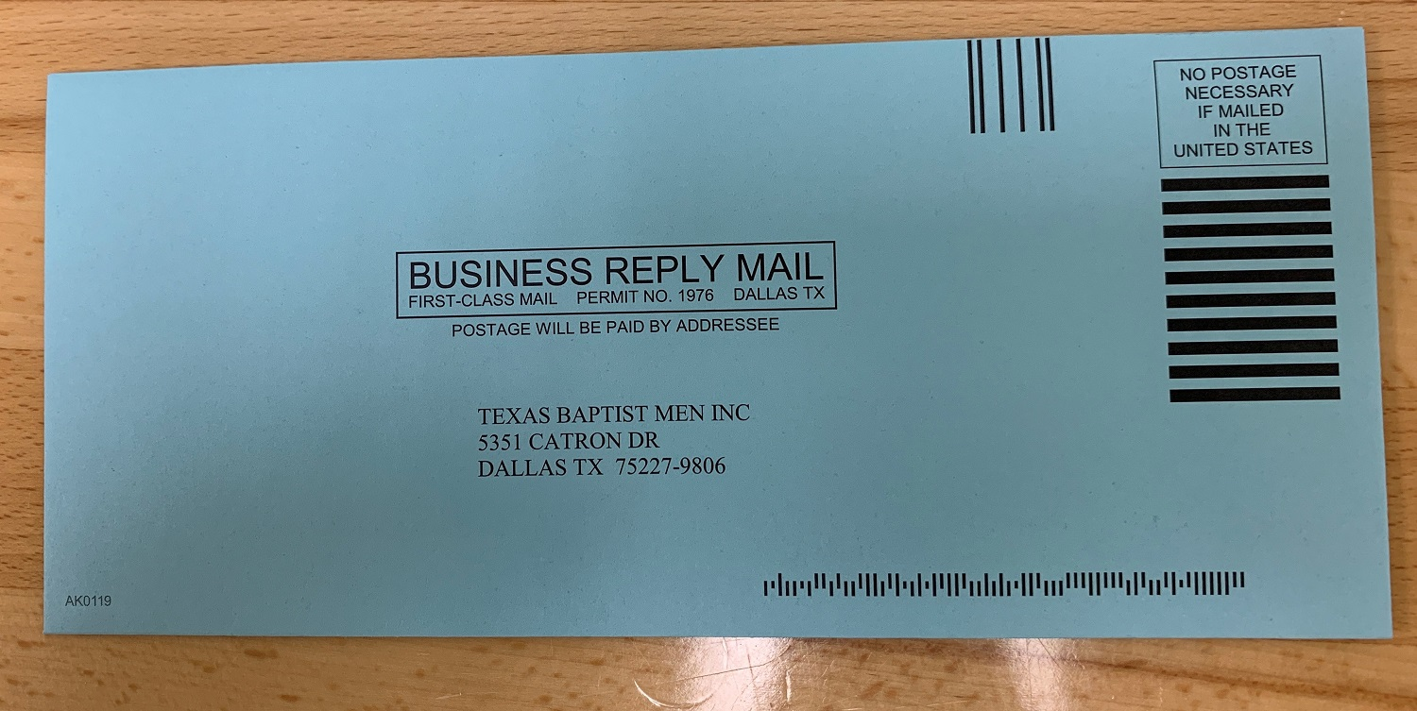

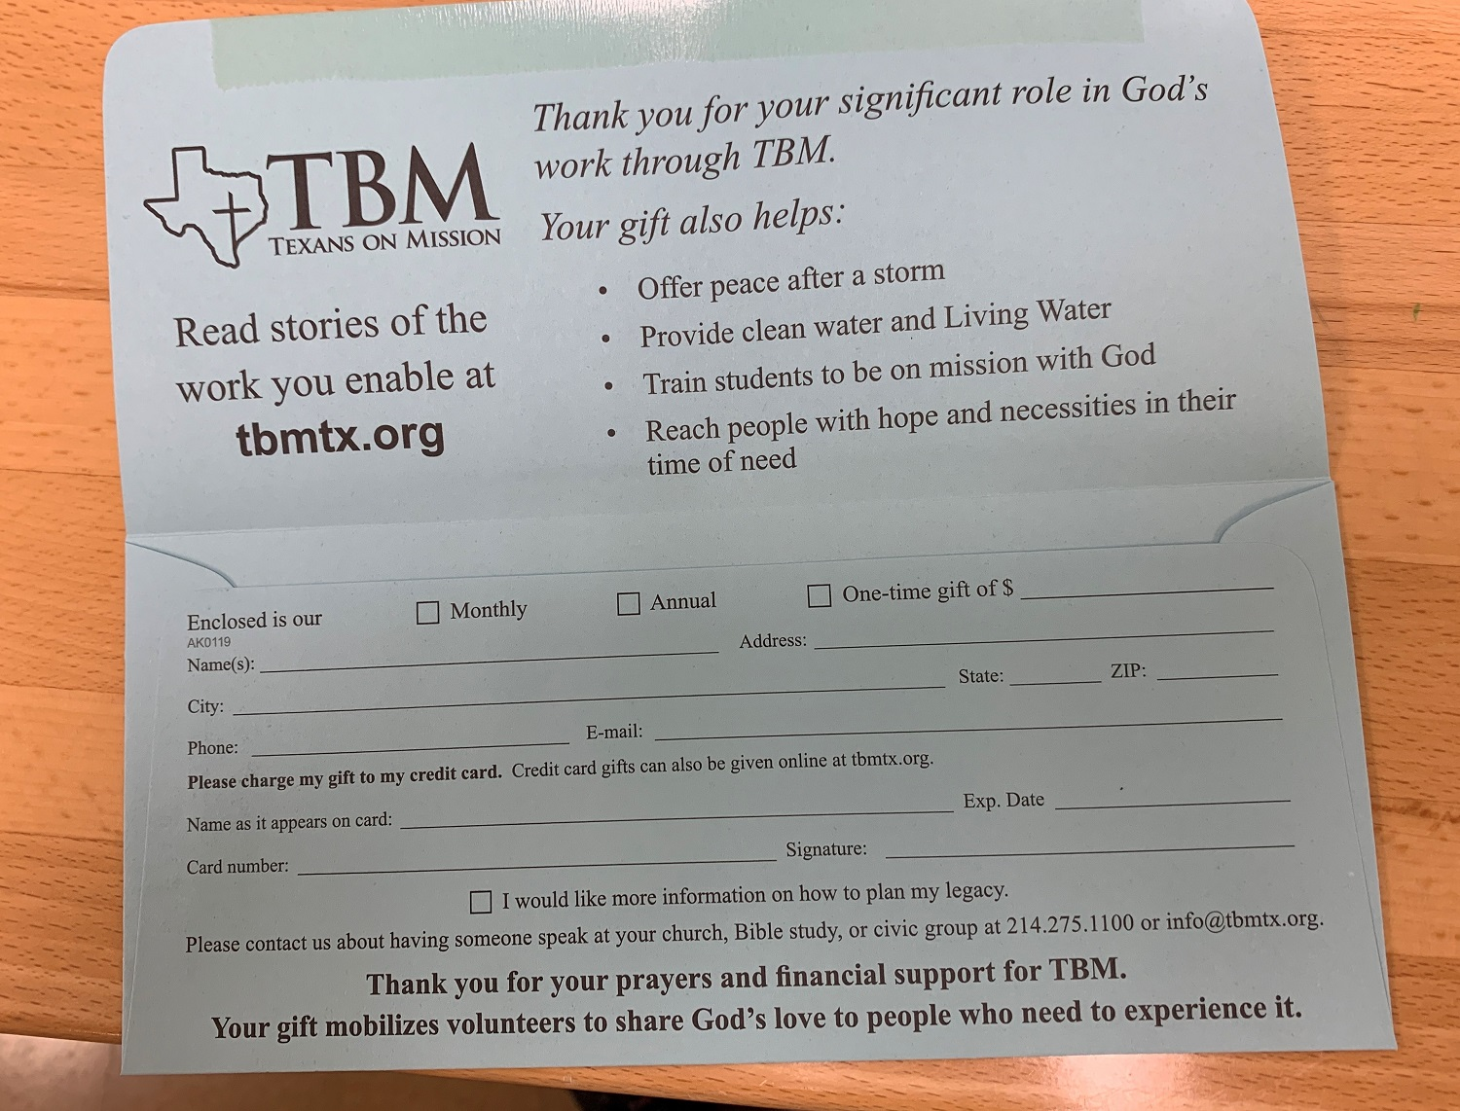

- Unit Leader Form Stack Check List (9/20/22)
NOTES:
- Always use the Response and Location as provided on the briefing sheet
- Always use your TBM supplied Unit number

Responding Team ROSTER Submission Form
- Submit as soon as team composition known.
- Roster must be submitted prior to deployment departure.
- Update as needed as roster changes.

Responding Team DEPLOYMENT Report
- Submit when team departs for the deployment site.
- Submit when team departs deployment site for home.

Reporting Team ARRIVAL Notification Report
- Submit as soon as possible after arrival at deployment site.
- Submit also upon arrival at home location after deployment.

DAILY Activity Report
- Submit daily while deployed including travel to and from deployment site.
- Rest days are reported as work days at 8 hours per volunteer.
- Reports must be submitted prior to 8:30 PM each day.
- The Evangelistic Response form is not used by TBM. Delete the form and the Daily Report form will be submitted.
- Professions of faith should be reported on the TBM provided form.

INCIDENT REPORT
- Submit as needed

SECTION 8 – BIBLE VERSES
- Life Verse for Unit Leaders
Mark 10:43-45 Holman Christian Standard Bible
“…..whoever wants to become great among you must be your servant, and whoever wants to be first among you must be a slave to all. For even the Son of Man did not come to be served, but to serve, and to give His life a ransom for many”
- Matthew 28:19 Holman Christian Standard Bible
“Go, therefore and make disciples of all nations, baptizing them in the name of the Father and of the Son, and of the Holy Spirit”
- Proverbs 27:17 Holman Christian Standard Bible
“Iron sharpens iron, and one man sharpens another”
- Ephesians 4:26-27 Holman Christian Standard Bible
“Be angry and do not sin. Don’t let the sun go down on your anger and don’t give the Devil an opportunity”
- Ephesians 4:29 Holman Christian Standard Bible
“No rotten talk should come from your mouth, but only what is good for the building up of someone in need, in order to give grace to those who hear”

SECTION 9 – TEAM LEADERSHIP SKILLS
- Decision Making
- Notes
- Rely on the Holy Spirit for wisdom and guidance.
- Decision making is a developed skill.
- Practice improves performance.
- Three Phases to making a decision
- Attention Phase
- Define the problem
- Determine who and what
- Analysis Phase
- Gather all of the facts
- Seek wise counsel
- Carefully consider all possibilities
- Application phase
- Make the decision
- Communicate the decision

- Stress Management
- Causes of Stress
- Disaster Situation
- Hurting people – Can’t help everyone
- Food and Housing Issues
- Long work hours
- Environment – hot, humid
- Unit Leader Response
- Pray
- Talk about the issues
- Temporary Intervention
- Time out for yourself and team
- Day off for yourself and team

- Conflict Management
- Causes of Conflict
- Personality conflicts
- Personal preferences
- Power issues
- Poor communication
- Unit Leader Response
- Pray
- Kind and compassionate
- Quick to listen, slow to speak
- Overlook minor things
- Deal with personal issues first
- Carry your own load
- Don’t judge others
- Don’t compare team members

- Maintain Balance

Notes
- Realize that you as a Unit Leader are not alone and cannot do all of the work. You have a team and the responsibility to maintain personal balance.
- “Take care of yourself, you can’t pour from an empty cup”
- Lead by Example
- A physically tired Unit Leader and team become strained emotionally and spiritually and take away from being “More Like Jesus”.
- Maintain personal Spiritual, Physical, and Emotional Balance.
- Be aware of your teams Spiritual, Physical and Emotional Condition
- Spiritual Balance
- Daily quiet time
- Team Devotions
- It’s all about Jesus
- Pray
- Led by the Spirit
- Depend on God’s grace
- Physical Balance
- Lead by example
- Proper rest
- Avoid mistakes and accidents
- Emotional Balance
- Stay calm in the midst of turmoil
- Think clearly
- Help relieve crisis situations
- Clear up misunderstandings
- Communicate clearly

